**KABARAK  UNIVERSITY**

DEPARTEMENT OF COMPUTER SCIENCE AND IT

**STUDENT FIRST AID AWARENESS SYSTEM**.

KIPKENY COLLINS: INTE/MG/2838/09/22.

ROSELYNE VENNESSA: INTE/MG/1930/09/22**.**

GEORGINA CHEPKORIR CHERUIYOT INTE/MG/1820/09/22**.**

CHRIS MUNYAKA - INTE/MG/3559/09/22

JANE WANJIRU-INTE/MG/3118/09/22

KELVIN MUTUA-INTE/MG/3538/09/22

**CHAPTER ONE: INTRODUCTION**

**1.1 Background of the Study**

Many students lack the knowledge and skills required to perform basic first aid. Injuries, accidents, and medical emergencies such as burns, cardiac arrests, nosebleeds, and seizures can occur in hostels, dormitories, and off-campus housing. When hospitals are far or inaccessible, the absence of first aid knowledge may worsen health outcomes or even lead to avoidable deaths.

To bridge this gap, a web-based platform that provides essential first aid training, emergency response tips, and opportunities to attend certification events can empower students to act promptly during emergencies. The proposed website will educate users with interactive and accessible content on core first aid skills like CPR and choking response, as well as emergency-specific advice like stroke symptoms and severe allergic reaction response.

**1.2 Problem Statement**

Students often lack basic first aid knowledge, and during medical emergencies, they may not receive immediate professional assistance due to distance from hospitals or lack of medical personnel. Without accessible guidance, these situations can escalate. There is a need for a digital platform where students can easily learn, refresh, and apply first aid knowledge while staying informed about related training events.

**1.3 Objectives of the Study**

**Main Objective:**

To develop a responsive website that educates students on first aid, emergency procedures, and related event opportunities.

**Specific Objectives:**

* To provide categorized, easy-to-understand first aid tips (e.g., CPR, bleeding, burns, etc.).
* To share actionable emergency tips for conditions like cardiac arrest, strokes, and trauma.
* To include a section for upcoming workshops and certifications to encourage participation in hands-on training.
* To improve first responders' confidence among students.

**1.4 Significance of the Study**

This project is significant as it:

* Promotes student health and safety.
* Helps bridge the first aid knowledge gap.
* Encourages proactive learning of life-saving skills.
* Supports institutions in their health and emergency preparedness initiatives.

**1.5 Scope of the Study**

The website focuses on educating university/college students on basic and advanced first aid techniques, emergency responses, and hosting event details. It will not provide real-time medical consultations but will act as a reference and awareness platform.

**1.6 Limitations of the Study**

* It depends on internet access.
* The website doesn’t replace professional medical help.
* Users must regularly visit the site to stay updated on events and new tips.

**CHAPTER TWO: LITERATURE REVIEW**

**2.1 Introduction**

This chapter explores related work, theories, and previous research on first aid awareness, digital health education, and emergency preparedness.

**2.2 Concept of First Aid**

First aid refers to the immediate assistance provided to a person suffering from an injury or illness until professional help is available. It involves simple techniques such as stopping bleeding, managing burns, and providing CPR.

**2.3 Importance of First Aid Knowledge Among Students**

Numerous studies highlight the benefits of first aid training in schools and universities. For example, the Red Cross emphasizes that trained individuals can save lives before emergency services arrive. Many institutions lack structured first aid education, leaving a knowledge gap among students.

**2.4 Related Systems and Platforms**

* **Red Cross Learning Center**: Offers online first aid training but requires registration and fees.
* **St. John Ambulance App**: Provides quick-access emergency tips but lacks academic event features.
* **Mobile apps (like First Aid by British Red Cross)**: Deliver concise first aid tips but may not be region-specific or event-inclusive.

These platforms lack an integrated view tailored to students and localized events.

**2.5 Review of Emergency Tips and Techniques**

* **Cardiac Arrest**: Early CPR and defibrillation significantly improve survival rates.
* **Burns and Trauma**: Immediate cooling and covering of burns reduce damage.
* **Stroke Symptoms**: Recognizing F.A.S.T. (Face drooping, Arm weakness, Speech difficulties, Time) is essential.
* **Allergic Reactions**: Immediate response with epinephrine (if available) can prevent anaphylaxis.

**2.6 Theoretical Framework**

The project is based on the **Health Belief Model (HBM)**, which explains how people's beliefs about health problems influence their readiness to act. The platform aims to enhance students’ perceived seriousness and benefits of learning first aid.

**CHAPTER THREE: METHODOLOGY**

**3.1 Introduction**

This chapter outlines the system development process, tools used, and the structure of the proposed website.

**3.2 System Development Methodology**

The **Waterfall Model** was adopted:

1. **Requirement Analysis**
2. **System Design**
3. **Implementation**
4. **Testing**
5. **Deployment**
6. **Maintenance**

This model is ideal for structured development and documentation.

**3.3 Functional Requirements**

* Users can read categorized first aid tips.
* Users can access emergency-specific instructions.
* “Call 911” functionality for life-threatening emergencies.
* Users can view upcoming events with date, venue, and description.
* Admin can update tips and event listings.

**3.4 Non-Functional Requirements**

* Mobile responsiveness
* Fast loading times
* Simple, clean UI/UX
* Accessibility features (font resizing, color contrast)

**3.5 Tools and Technologies**

* **Frontend**: HTML5, CSS3, JavaScript
* **Backend**: PHP (optional: Node.js or Python Flask)
* **Database**: MySQL
* **Hosting**: XAMPP (for local development)

**3.6 System Modules**

**1. First Aid Tips Module**

Includes articles and instructions on:

* Severe bleeding
* Nosebleeds
* CPR
* Choking
* Burns
* Seizures

**2. Emergency Tips Module**

Contains emergency response guidelines for:

* Cardiac arrest (includes "Call 911" button)
* Stroke
* Allergic reactions
* Major trauma

**3. Events Module**

Lists upcoming events such as:

* CPR certification courses
* Disaster response workshops
* Youth first aid camps  
  Each includes time, venue, registration info, and brief descriptions.

**3.7 Database Design (simplified)**

* **users** (optional): user_id, name, email
* **tips**: tip_id, category, title, content
* **emergencies**: emergency_id, title, steps, urgency_level
* **events**: event_id, name, description, date, location

**3.8 Security Considerations**

* Admin login for content management
* Input sanitization to prevent injection attacks
* HTTPS recommended for deployment

**PERSONA**

### Name: Sarah Wanjiku

* **Age**: 21
* **Education Level**: Undergraduate, 3rd Year Public Health Student
* **Location**: Nairobi, Kenya
* **Tech-Savvy Level**: Intermediate
* **Goals**:
  + Learn how to perform CPR and handle choking emergencies.
  + Be able to assist her hostel mates during medical emergencies.
  + Get certified in first aid.
* **Frustrations**:
  + Doesn’t know where to find reliable first aid information quickly.
  + Finds online resources scattered or too technical.
  + Misses training events because she doesn't know when they are happening.
* **Preferred Devices**: Smartphone and laptop

**Quote**:  
“I want to be the kind of person who can help when someone collapses or gets injured. But where do I even start learning?”

**EMPATHY MAP**

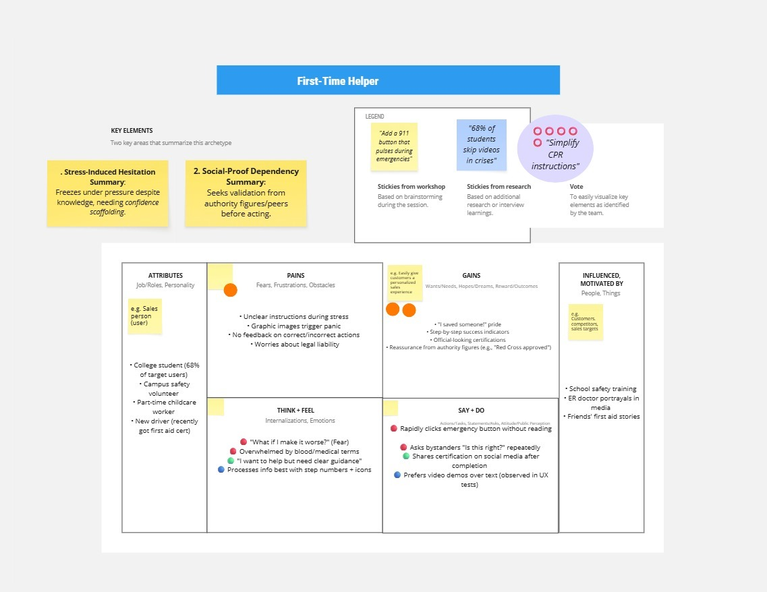

**1st level DFD**

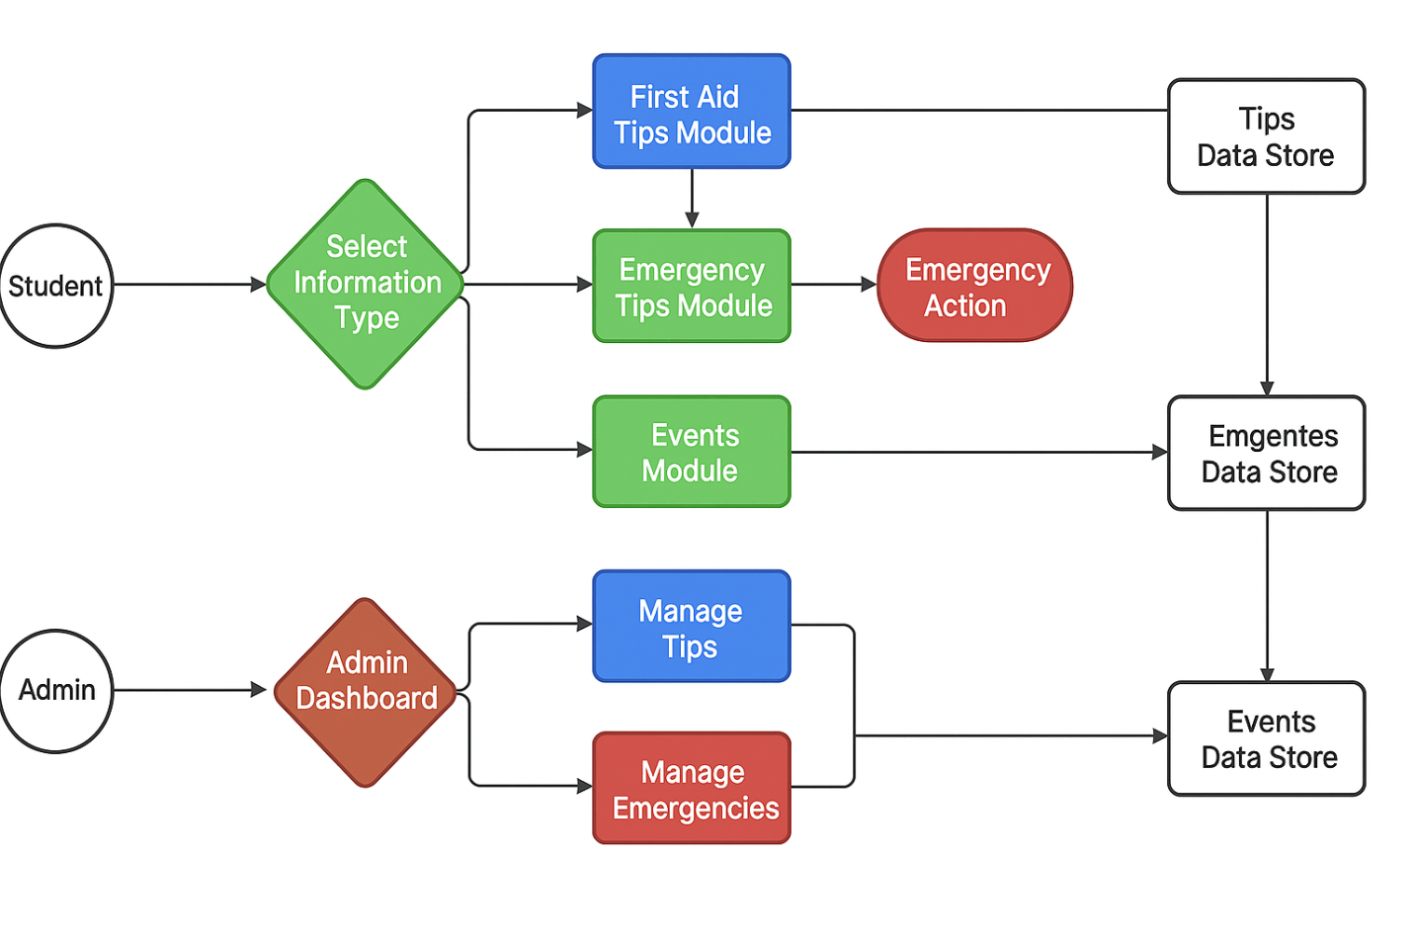

**USE CASE DIAGRAM**

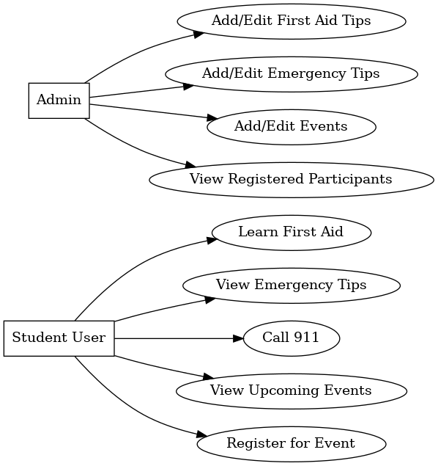

**CONTEXT DIAGRAM**

